 APS Meeting 2015 
22-24 February 2015

Scitech Planetarium, City West, Sutherland St, West Perth, 6005

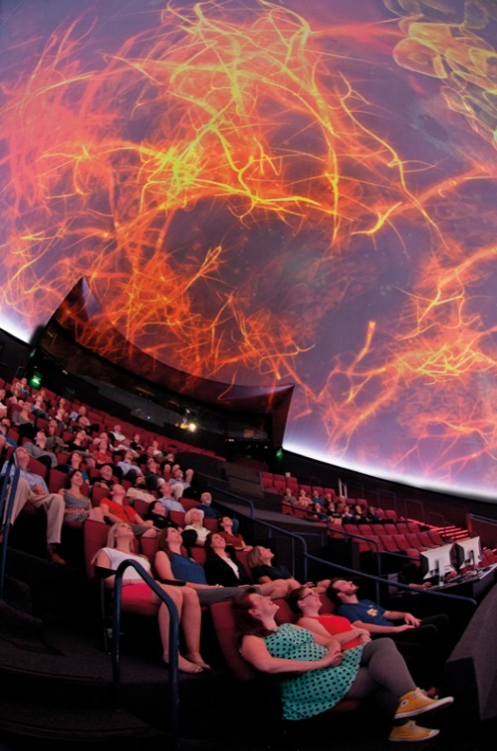
The Australasian Planetarium Society meeting in 2015 will take place on 22-24 February at the Scitech Planetarium located in the City West complex, West Perth. This will be an excellent opportunity to network with operators of both fixed and mobile planetariums.
There will be a registration fee of $35 per attendee.
The planetarium demonstrations are open to members and non-members. The sessions are included for all members. Non-members may attend at the rate of A$30 (half-day), A$50 (full day) or A$70 (both days). Morning teas and lunches will be provided for all attendees. The APS Dinner on Monday night is free to non-commercial members thanks to sponsorship by Sky-Skan. Breakfasts and Sunday night dinner are at your own expense.
Around this time the Scitech Planetarium will also be holding its inaugural Dome Screen Festival, from the 20-25th February. This festival will be highlighting the amazing work and variety of Australia’s (dome) visualisation community. We will be holding presentations, visualisation and music sessions just to name a few. On the evening of Saturday 21st we are having a special music under the dome event.
The APS AGM will take place on Monday the 23rd of February. Please note that only financial APS members will be entitled to vote at the AGM. All members will receive renewal notices prior to the conference. Non-members may attend and speak to the meeting only at the discretion of the APS executive.
For details about Scitech and how to find us, please visit our web site: http://www.scitech.org.au/

Please forward any enquiries to:
Jeff Harris: ph. (08) 9215 0830 email: jeff@scitech.org.au
Simon Robinson: ph. (08) 9215 0832 email: simon.robinson@scitech.org.au

Kind regards,
Jeff Harris, Manager, Scitech Planetarium

CALL FOR PAPERS
The call is open for all institutions and vendors to submit presentations they would like to deliver during the meeting. Presentations can be either a normal power point style talk, or material (including shows) that can be screened on the planetarium dome. Please put forward your presentations to Jeff Harris. For information on the Scitech Planetarium dome set-up and slicing of material, please also contact Jeff Harris.

2015 Schedule - draft

Sunday 22nd
10.30am – 1.00pm | Sky-Skan:  Digital Sky Academy Session
1.00 – 4.00 | Free time
4.00 – 5.30 | Dinner – location TBA
5.30 – 6.00 | Walk to Scitech
6.00 – 8.00 | Spinning the Cosmic Web on a Supercomputer *

*On the evening of the Sunday 22nd February there will be a special presentation from the scientists at International Centre for Radio Astronomy Research about their research on Dark Matter and galaxy formation. This is a fascinating talk and includes some full dome visualisations they created especially for this presentation using software they wrote themselves.

Monday 23rd
8.30 – 9.00 | Morning Coffee
9.00 – 9.05 | Welcome to APS 2015
9.05 – 10.00 | Sky-Skan:  Space School – Blue World (TBC)  Dream to Discovery – Boston Museum of Science (TBC)
10.00 – 10.30 | TBA
10.30 – 11.00 | Morning Tea – sponsored by SoftMachine
11.00 – 11.30 | SoftMachine presentation
11.30 – 12.00 | Melbourne Planetarium: Starlight
12.00 – 12.30 | Sky-Skan: Journey to a Billion Suns – Stargarten/ESA (TBC)
12.30 – 1.00 | Lunch
1.00 – 2.30 | APS AGM
2.30 – 3.00 | Afternoon Tea
3.00 – 3.15 | Travel to Pawsey / HIVE
3.15 – 5.00 | Pawsey centre / HIVE tour **
5.00 – 5.30 | Travel to Scitech
5.30-7.00 | Free time
7.00 – onwards | APS Dinner – sponsored by Sky-Skan

**WA is home to the SKA mega science project and on Monday we will be visiting the Pawsey Supercomputing Centre which is home to the most powerful supercomputer in the Southern Hemisphere. Then heading across the road to visit Curtin’s HIVE (Hub for Immersive Visualisation and eResearch) which is an advanced new facility established by Curtin University to serve the growing demands of researchers and industry for visualisation, virtualisation and simulation capabilities in Western Australia.

TBA – To Be Announced

Tuesday 24th
8.30 – 9.00 | Morning Coffee
9.00 – 10.00 | Sky-Skan:  Definiti system developments -2015/16  DigitalSky visualisation and dataset update for 2015  Sky-Skan :  Bella Gaia - Kenji Williams/Remedy Arts
10.00 – 10.30 | Morning Tea
10.30 – 11.00 | Full dome show – TBA
11.00 – 11.30 | Sky-Skan:  Space Junk – Melrae Pictures (TBC)
11.30 – 12.30 | Zeiss presentation
12.30 – 1.00 | Lunch – Sponsored by Zeiss
1.00 – 1.45 | Mysteries of the Unseen World – National Geographic (TBC)
1.45 – 2.00 | Break (leg stretch)
2.00 – 2.45 | Pandas: The Journey Home – National Geographic (TBC)
2.45 – 3.00 | Afternoon Tea
3.00 – 3.45 | TBA
3.30 – 4.00 | TBA
4.00 – 4.15 | Break (leg stretch)
4.15 – 5.00 | TBA
5.00 – 5.30 | Farewell and close of APS 2015

Some close accommodation to Scitech

Quest Apartments
Walking distance from Scitech and three locations to choose from:
Quest on James
Quest on Rheola
Quest West End
As Quest has grown, our goal remains unchanged: to provide conveniently located, stylish and spacious accommodation to business travellers, no matter where they are travelling.
http://www.questapartments.com.au/#/map/

Four Points by Sheraton
Get everything you're looking for with style and service you want, all at a great price. We have what matters most to you like stylish rooms, comfortable beds, delicious breakfast and fresh coffee. Plus lots of other extras you'll love like free bottled water in your room, free internet access, and great local beer.
http://www.starwoodhotels.com/fourpoints/index.html

City Stay Apartment Hotel
Located in West Perth, City Stay Apartment Hotel offers spacious and comfortable, 3½ star apartment accommodation on Perth's main street, just 1.4km down from the Perth GPO.
http://www.citystay.com.au/

